*Appendix*

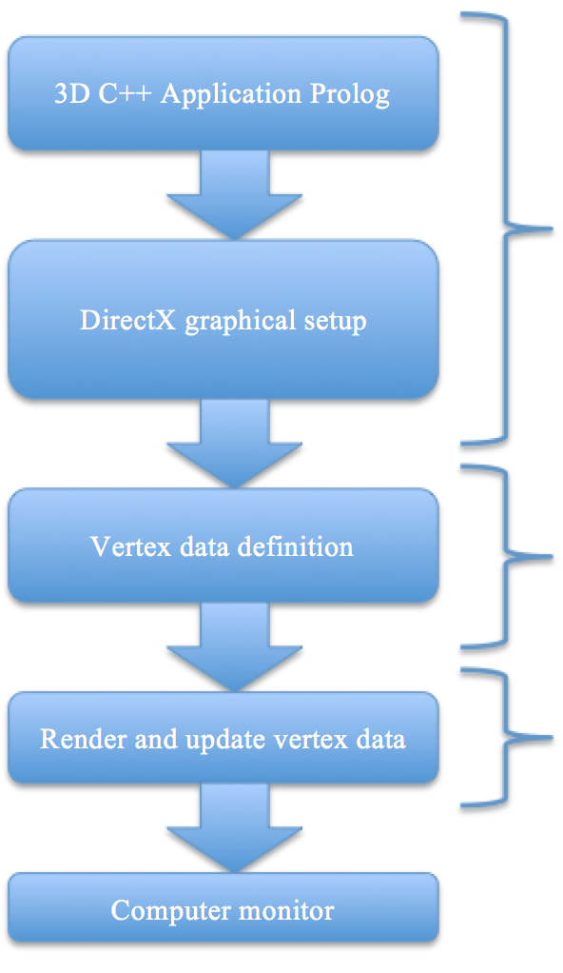

*I – Understanding the third dimension from a computers point of view*

*II – The importance of triangles*

*III – Drawing a primitive*

*IV – The Graphics Pipeline*

*V – Motion, matrices and programming*

*VI – Text and extension.*

*VII - Conclusion*

*NB: this appendix diagram serves as an illustrative for each chapter, referring back to it will help understand each procedure.*

*Prolog*

Up to this day, accomplishment has been far from the prime objective. The focus of the investigation this far has to been to set sights on how, from a hardware perspective, 3D graphics are displayed on a computer screen. This brings me to my very first point of explication.

It is very important at this stage to note (for both the author and reader) that 3D graphics are a crossover between Mathematics, Geometry and Computer Science, this point is very ambiguous on various online sources – I can quote no reference from my Bibliography, for example, that makes a clear statement about this, which is a real issue from my point of view, as most sources/references try to explain 3D graphics from the perspective of a programmer, which can quickly become an issue for someone who is less mathematically apt.   
In my review, presentation and artefact, I will attempt to explain the third dimension, 3D graphics programming and the informatics involved in very broad and mixed terms. This will enable both myself and the reader to understand the various implications of Mathematics, Coordinate Geometry, and Programming involved in computerized 3D graphics.

It is around these principles that I have attempted to formulate a concept for an artefact, which until September [see log] proved a tricky challenge; faced with an investigation that broadens itself to more complex Mathematics and, for the most part, advanced C++ programming, and only one study [Computer Science] though which to explain it, I had to find a way of conveying my research in brief, explicit and understandable terms. I also quickly came to the realization that it would be complicated to explain 3D in Computer Science terms without [for the most part] paraphrasing most of the content originally posted by authors sited in my bibliography. I came to the conclusion that I needed a new way to convey the essentials, a new way of explaining the processes I was employing to write what would be my very own 3D-demonstrative-artefact. It wasn’t until later that I realized the solution was clear all along. I would implement into my artefact a display of realtime information to the user, so as to better illustrate what I am explaining within my research documents. Information of this kind might be “Rotating in x-axis 1 radian per processor cycle”.

Adopting this model for my artefact would be much better fitting for the purpose of understanding when referencing my research from the artefact or vice-versa.

1. **Understanding the third-dimension, from a computers point of view**

From our own eyes, the third dimension seems like a natural perspective, but for a computer, there’s no such thing as the third dimension, and this point is key.   
For a computer, all there is to 3D is pixels displayed on a monitor, so it can stream is 2D. This, however, is sufficient.

  
 *Figure 1*

From *Figure 1*, the image of the cube, when bitmapped to the screen by a computer, is technically still a 2D image with *depth* to it. The way a computer would see a cube drawn to the screen is as shows:





*Figure 2*

*Figure 2* illustrates the cube superposed over Cartesian Planes, which is how a computer maps any image, 2D or 3D, to a computer monitor via a stream of binary. The cube is broken down to pixels, which are then assigned Cartesian Coordinates. Similar to how we map Curves of Equations in Mathematics. This, however, does still not help us, as a computer can’t produce a cube immediately.

**II. The importance of triangles**

In the case of this investigation [which covers DirectX, the most widely used 3D SDK] we have what is called *primitives*, which are a collection of what we call vertices, the plural of vertex, which is a coordinate in our Cartesian Planes, like in *Figure 2*. These primitives can form any possible 2D shape in the world, as they’re just points joined together. But when combined to make shapes such as triangles, these primitives become very powerful.   
[*Further reading, Nussbaum, Doron, Drawing Primitives*]

*< Figure 3,*

*Figure 4 >*

(Microsoft 2013)

As illustrated in *Figure 3* and *Figure 4*, we can combine triangles to make complex geometric shapes, such as a cube, with 2 triangles composing each face. Or even more complex, a coarse circle.   
“The power of triangles is not limited to basic shapes” (*DirectXTutorial.com, 2010*), we can create anything with triangles, as illustrated in *Figure 5a and 5b*.

*Figure 5a*

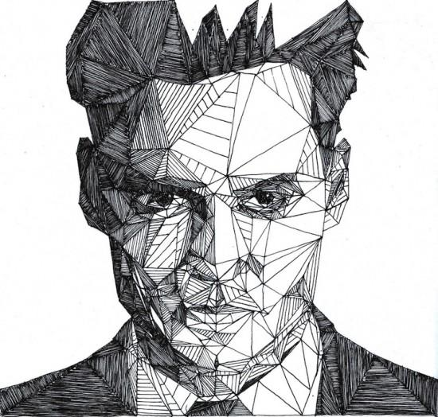

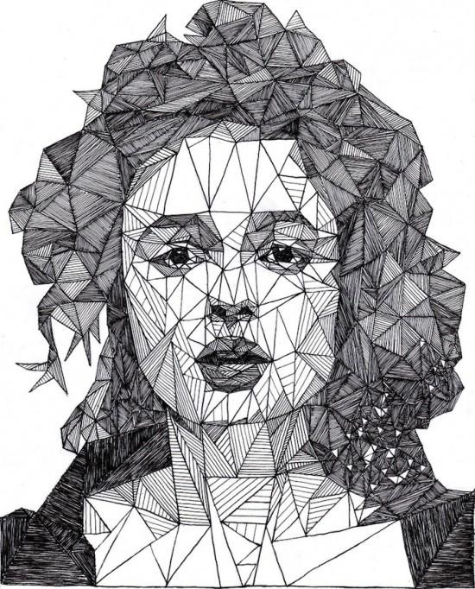*Figure 5b*

As observable above, triangles can be used to create anything desired. From cube to face, everything is possible, and to any degree of accuracy, depending on how many triangles/square unit – allowing for better curvature.

We can hence establish a hierarchy as follows (from bottom to top):

1. Vertex

2. Primitive

3. Triangle

4. Triangle strip (e.g: *Figure 5a & 5b*).

By now, it’s safe to assume that anything we wish to render in 3D Graphics is going to be made of triangles, so let’s talk about the different types of triangle-collections possible. The three main collections of triangles are: triangle strips, triangle lists and triangle fans.

In the case of this report, we can neglect the usage of triangle fans. Triangle strips and triangle lists can be represented in the following manner –

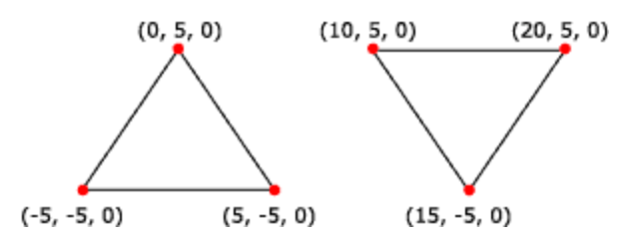 (Source: MSDN – Triangle list) *Figure 6*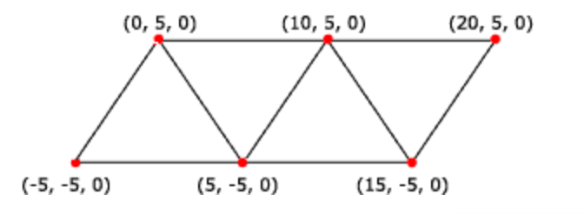 (Source: MSDN – Triangle strip) *Figure 7*

Within C++ code, these triangles are stored as an array of coordinates – which are then individually rendered to the screen and attached together.

**III. Drawing a primitive**

Primitives are basic geometric shapes, such as discs, cuboids, and cylinders. All of which can be draw with triangles (*Figure 3 and 4, Microsoft, 2013*) (*Figure 5a & 5b, Josh Bryan’s Triangulations*).

Expanding on triangle strips and triangle lists, we can obtain any object we like, where resemblance and “how realistic it looks” are factored by scale – say in *Figure 5a or 5b*, for example – increasing the amount of triangles used to draw the eye sockets would allow for more curvature – and hence a more realistic face. This being said, it will not be of importance in either the report or artefact, as this investigation only builds on cuboids, which are already of high complexity to draw.

It is also an interesting point to note, when graphics escalated from 8-bit to 32-bit, and as graphics processing got more and more powerful *1, the amount of vertices *2 that could be processed per frame increased greatly, which means that the graphical imagery generated could be more and more realistic, as there was more and more curvature possible, as defined above.

The above defined modern day game creating, and what allows for better 3D graphics.

*1 - or graphics hardware got more VRAM, such as graphics cards

*2 - edges, or ‘corners’ of the abovementioned triangles

First of all, defining a list of 24 vertices as so – 4 vertices for each face of the cuboid, a face is constructed as so: *Figure 8,(Charles Downs)*

*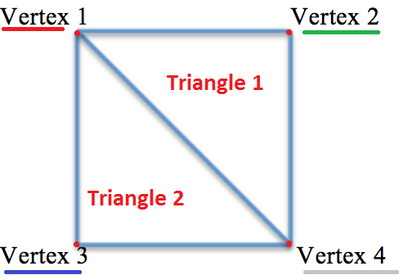Each vertex has it’s own coordinate,*

*Where vertex 1 and 3 share the same*

*x-positioning, 1 and 2 share the same y-positioning, 2 and 4 share the same x positioning and 3 and 4 share the same y-positioning, although 4 parameters are possible when in 3D, although this is not exactly what we’re dealing with at the moment, as we will combine 4 quads to draw a 3D cube.*

Figure 8 is an example of a triangle strip, explained in **II**. The precedent C++ would be as follows-:   
Vertex vertices[] = { {x1, y1, z1}, {x2, y2, z2}, {x3, y3, z3}, {x4, y4, z4} };

Where each x, y and z are components (coordinates) of each Vertex 1, 2, 3 and 4.

**Note:** It is extremely important to explicitly define within the program what kind of vertex list is being graphically processed (triangle list, strip …) in the case of *Figure 5 and 7*, a triangle strip (*Nussbaum, Doron – Drawing Primitives, accessd 2014 – Further reading*).

Defining 6 vertices as demonstrated above, one for each side of the cuboid, totals 24 vertices (or coordinates).   
Before being able to yield these instructions to the video card RAM, we will need to unlock a segment of VRAM the same size as out 24 vertices, unlocking this memory will give us write access to that region, so we can insert the vertices ready to be graphically processed, as by default, VRAM is locked. By this point, we’re ready to pass instructions through the graphics pipeline.

**IV. The Graphics Pipeline**

Schematically, we’ve covered the first three sectors of the appendix diagram, which leaves only the Render and Update section. Rendering and Updating is encapsulated by The Graphics pipeline.

Before explaining the Graphics Pipeline, it’s important to elaborate on backbuffers.

A backbuffer is a buffer that holds the next “scene” to be rendered, or the next image that needs to be drawn to the screen, the reason for a backbuffer is to overcome the 60Hz refresh rate limitations of monitors (*DirectXTutorials.com, accessed 2013*), it allows us to have a prepared image that we can immediately draw to the screen when the current scene has terminated, and for that reason, we always copy our graphical data to the backbuffer.

Schematizing: - *Figure 9, Charles Downs*

Geometric (vertex) information

Graphics pipeline

Backbuffer

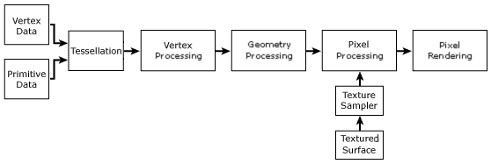Where the full graphics pipeline is as follows- *(Figure 10 Microsoft, 2013)*

In what concerns this investigation, the Graphics Pipeline will not be a point of explication, as many of the procedures involved in the pipeline are not fundamental to understanding computerized 3D graphics.

**V. Motion, matrices and programming**

From this chapter onwards I will redact in the first person so as to convey my own experience investigating this matter, assuming that by this point that I had finished researching how I could create a 3D application and that I was ready to engage into the creation of the application (*Ber'Zophus, accessed 2014, further reading*).

*See the following figures for my achievements timeline.*

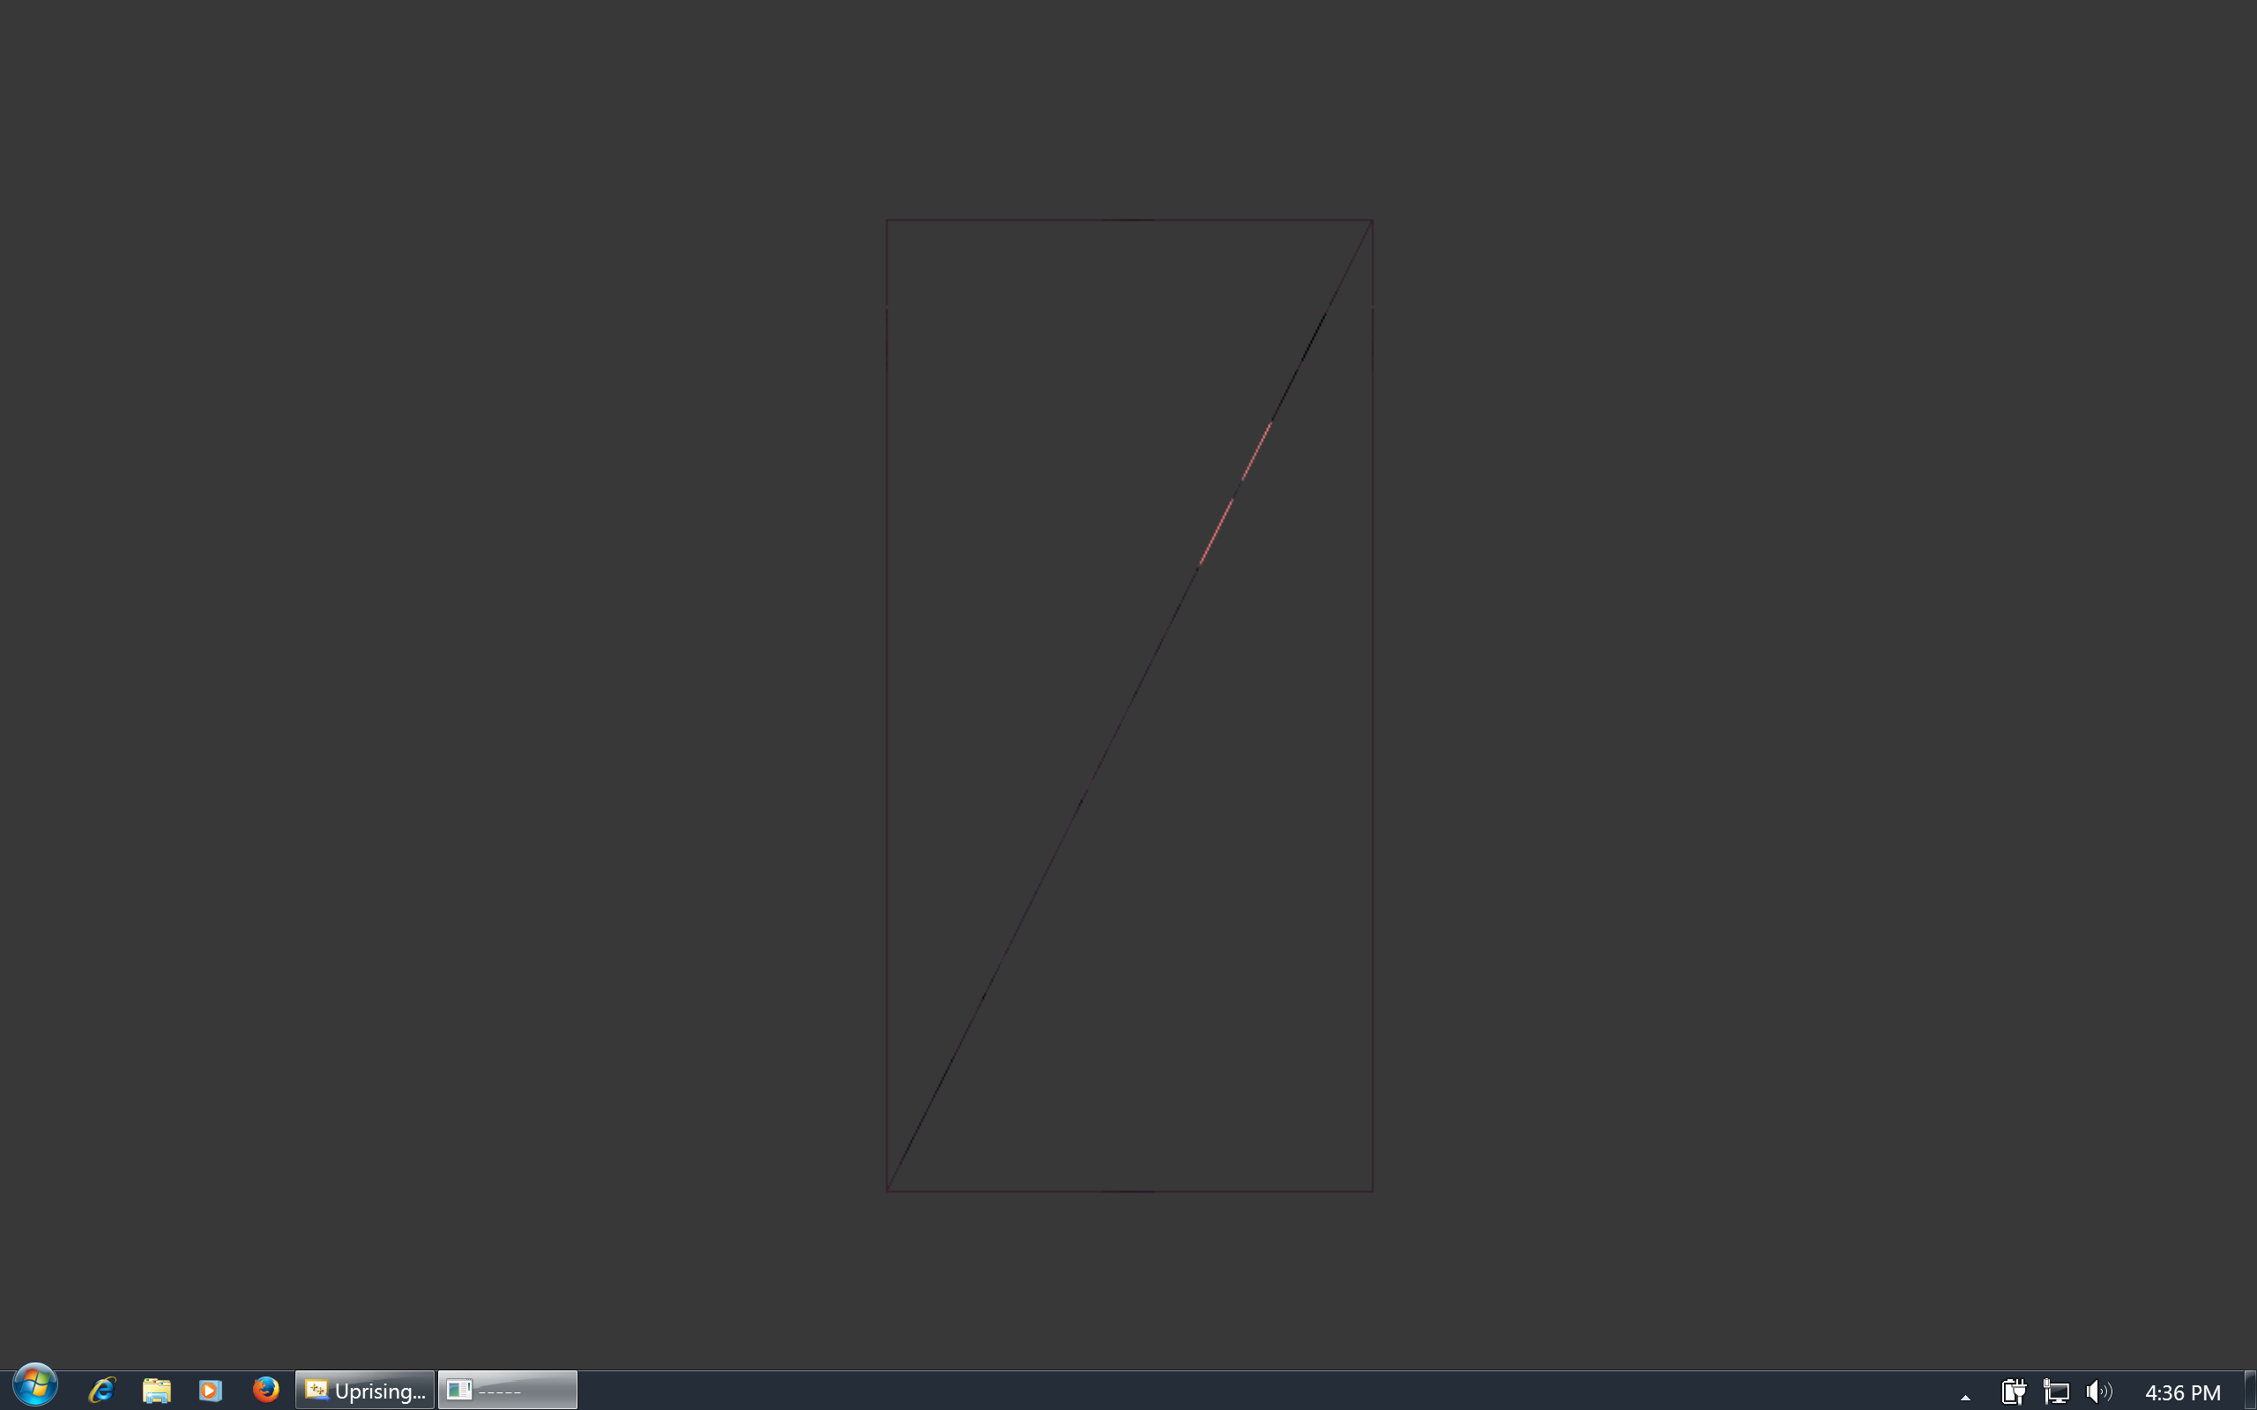From the 18th of January (quote Diary.txt), I started writing my final artefact, with a quad built from 2 triangles as a base, as follows:

Extending my research from **III**, I was able to add a 3rd dimension to my original model –

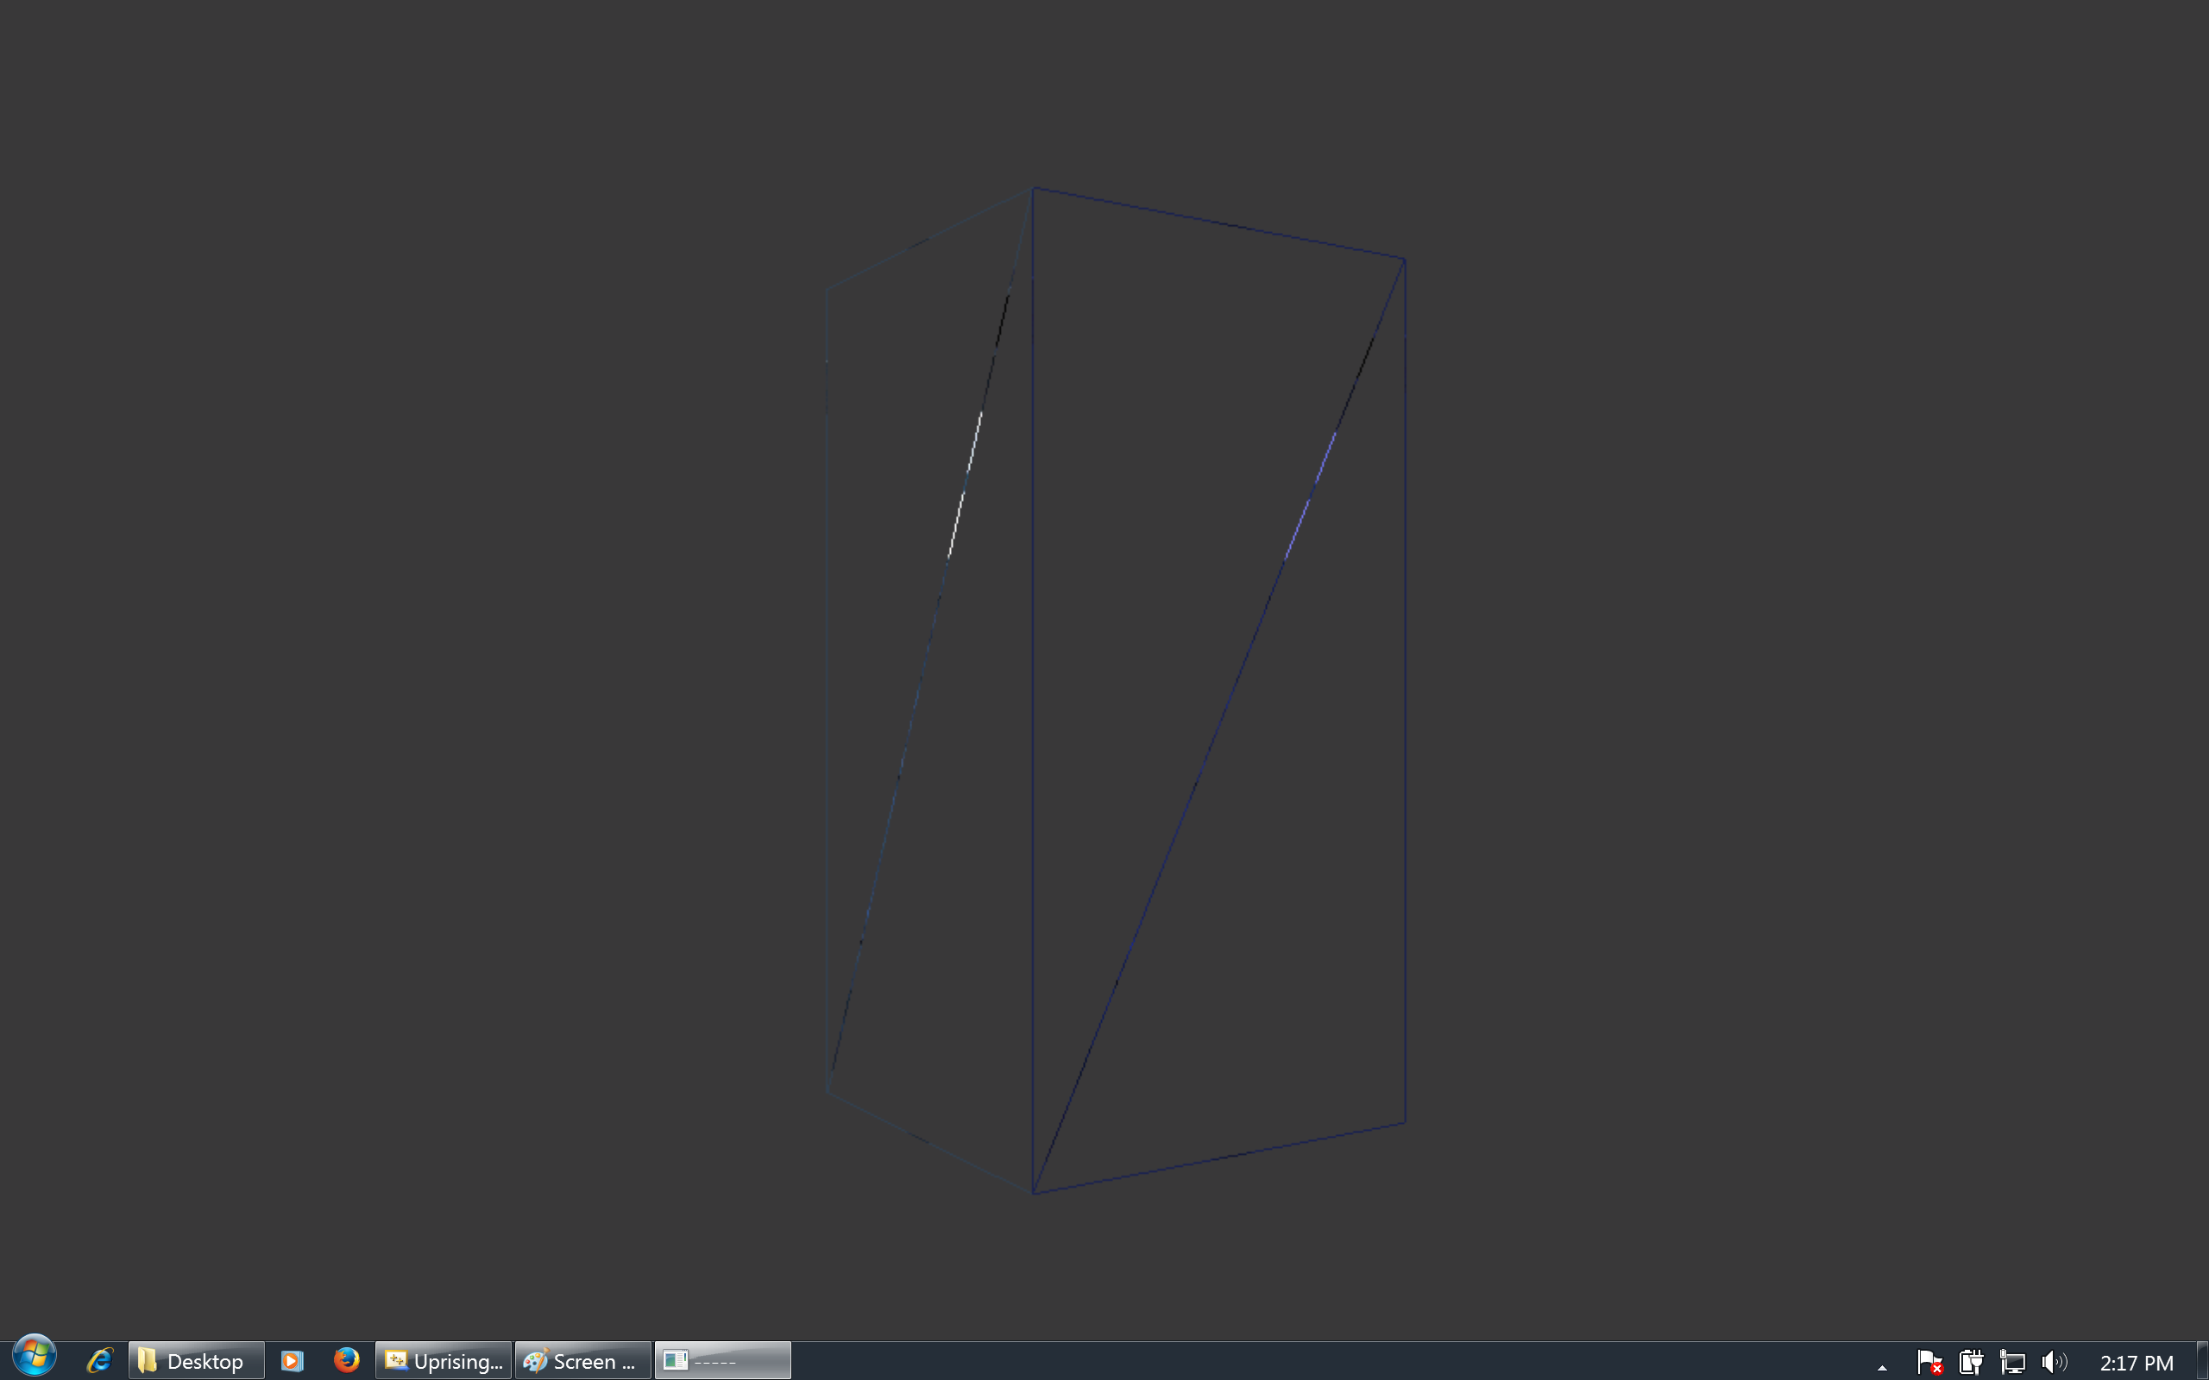

Adding a texture gave me a more familiar object –

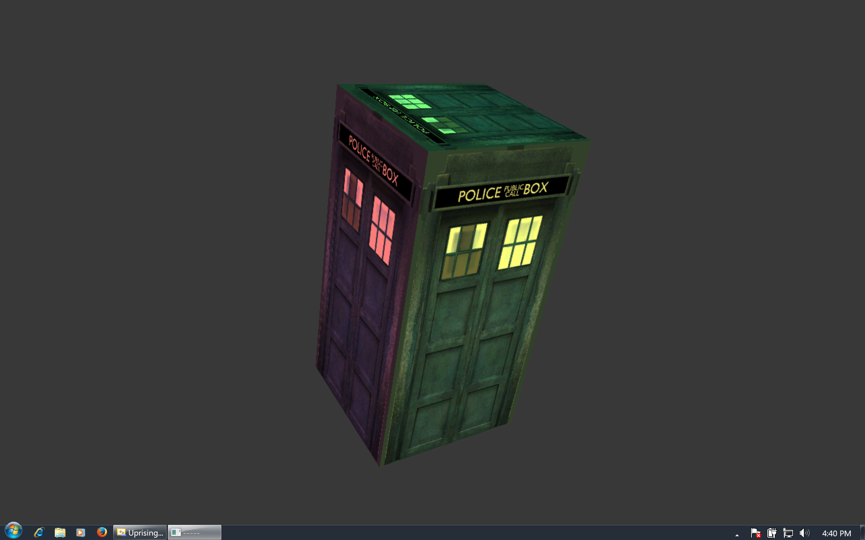

Next, I had to give my artefact some motion; doing so would involve what is called a matrix. Here is where I encountered the first “split perspective” issue; it was difficult to find a definition that was the union between mathematics and informatics. To illustrate how a matrix is used, I will quote a slide from my presentation which explains both the mathematics and informatics.

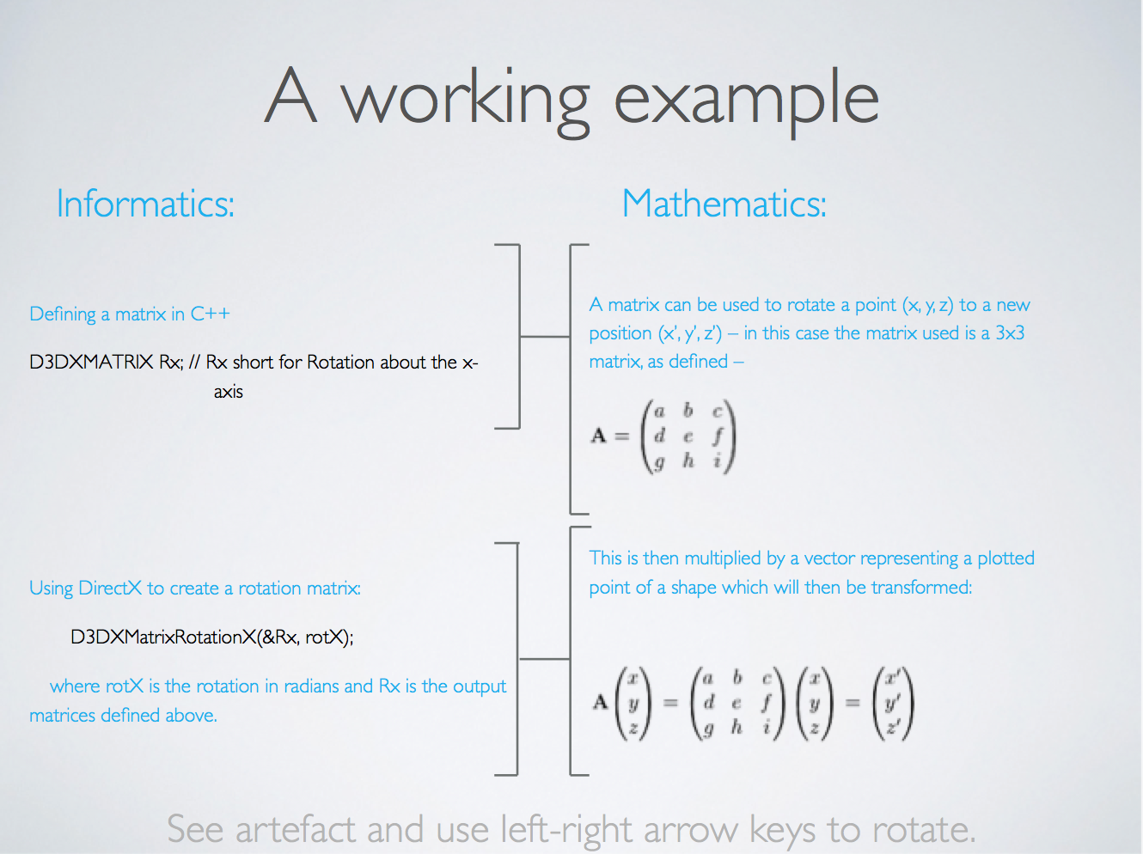

Using the artefact to demonstrate the outcome of the investigation:

* Using the arrow keys rotate it around x and y-axis.
* Using ESDF keys will transform in x and y-directions.
* Using left and right click will transform in z-direction.

**VI. Text and extension**

By this point I was interested in adding some text to my 3D application, to display technical information on what is currently being processed.   
I learned to display text via an excellent online paper (*Two Kings.* Unknown, accessed 2014), which explained the principles of loading a font, copying a string to a text class instance, within hours, I had a flow of text displaying itself in the top right corner displaying information to the user when rotation or translations are applies.

Upon completion of the application I started to wonder how I could extended it to new horizons, to do this, I started thinking which part of the project was the most tedious. After minutes, I realized the most laborious parts of the programming were manually defining all the vertices (coordinates) to draw the shapes I wanted to display.

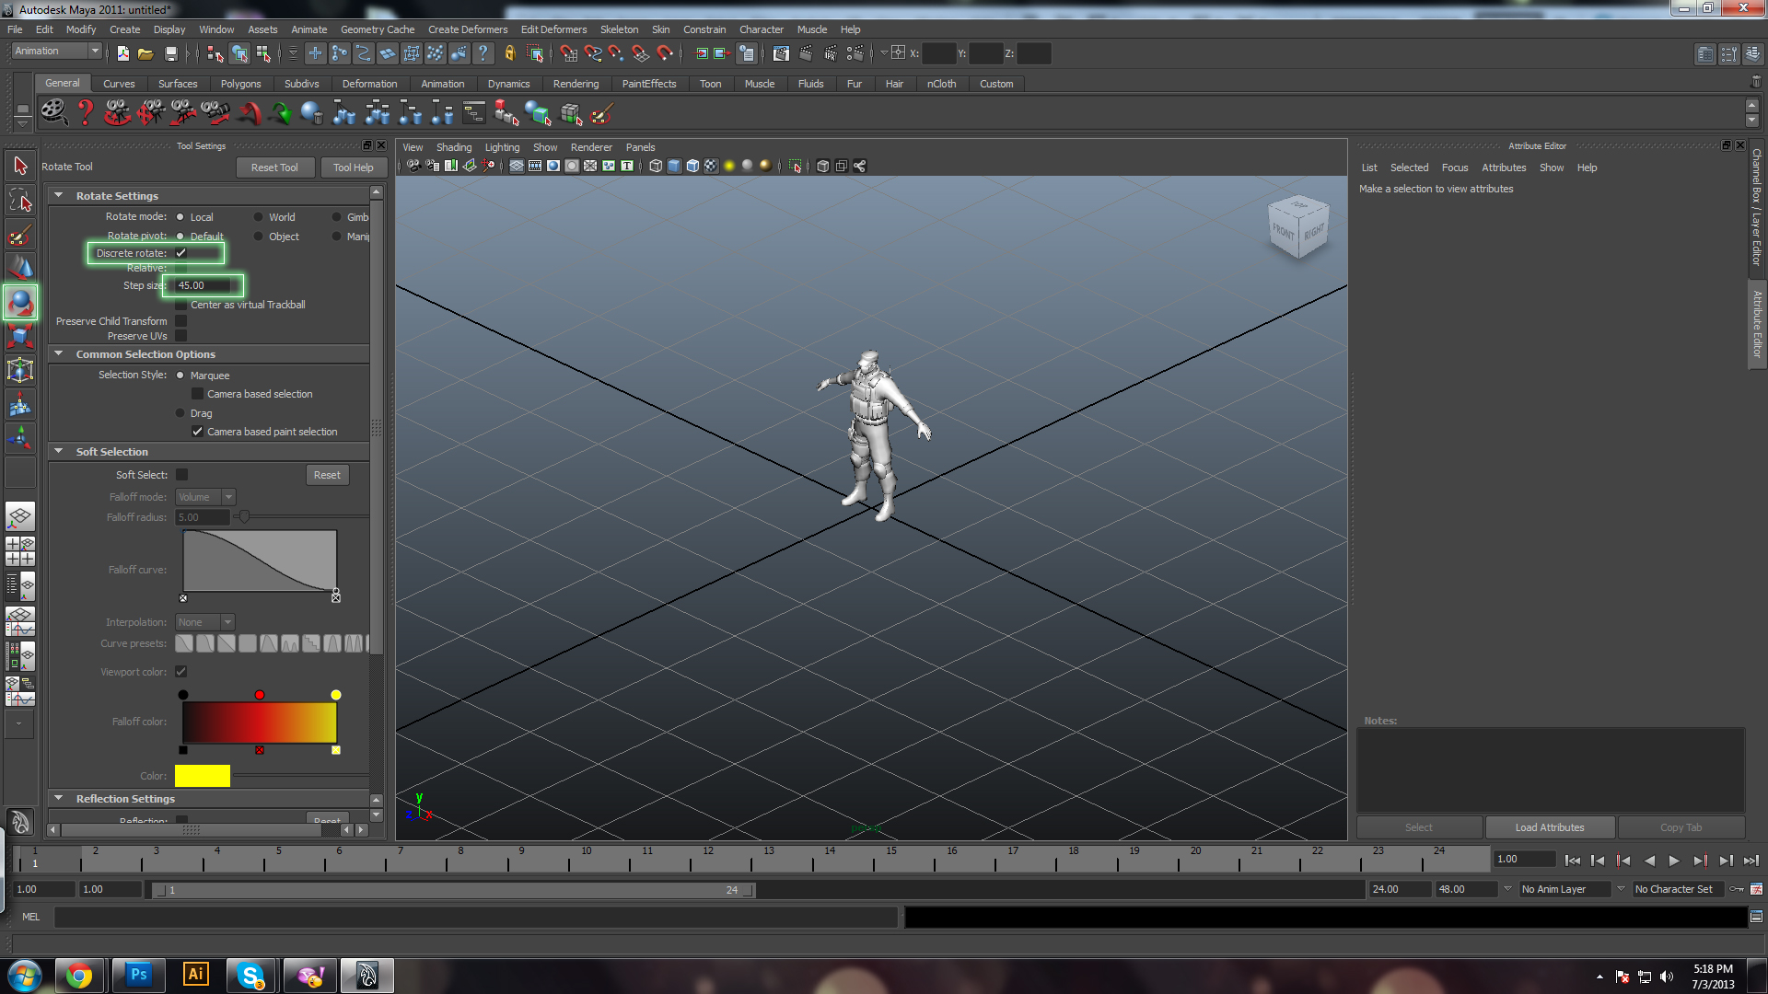Getting the positioning accurate for a cube took about an hour. It seemed obvious that the area in which I could improve my application was in the vector data field. Nowadays, modern and advanced commercial software can be purchased to draw extremely realistic and complex shapes, such as cars, humans, animals, and any kind of décor. Examples of these software packages are the AutoDesk suit, of which is comprised Maya, the most advanced model designing software: *Figure 11*

Maya stores all the graphical information relating to a model, such as the one above, inside a vector graphics file. Creating models is much easier than manually defining each vertex and each triangle.   
Extending my application so it has a C++ class that can read vector information from a vector graphics file would allow me to display very complicated models very easily.   
Having designed a model inside of Maya, I would then parse the file to my application, which would depict all the vector data and display it accordingly.

**VII. Conclusion**

By now – *March 2014, diary.txt* – I was in possession of my fully functional artefact, ready to be presented. During the month of March, I was reading over many materials I had used previously (see Further Reading), making sure my application was written efficiently, satisfied with my final product, I drew my EPQ concluded.

In conclusion, the EPQ experience aided me all across my A-level studies. The experience has extended my knowledge of the courses that I study, and given me new skills such as independent research, organization skills and an idea of what I would be faced with at career-level and university-level.

# Bibliography

DirectXTutorial.com. *DirectXTutorial.com.* 2010. DirectXTutorial.com.

Microsoft. *MSDN.* 2013. http://msdn.microsoft.com (accessed 2013, 2014).

Nussbaum, Doron. "Drawing Primitives ." *Drawing Primitives .* 2003.

# Further reading

Ber'Zophus. *zophusX.* 2005. http://zophusx.byethost11.com/main.php (accessed Feb 2014).

DirectXTutorial.com. *DirectXTutorial.com.* 2010. DirectXTutorial.com.

Guerrette, Matt. "[C++ DirectX 9] Tutorial." *[C++ DirectX 9] Tutorial.* May 28, 2013.

Kings, Two. *Two Kings.* Unknown. http://www.two-kings.de/tutorials/dxgraphics/dxgraphics09.html (accessed 2014).

Microsoft. *MSDN.* 2013. http://msdn.microsoft.com (accessed 2013, 2014).

Nussbaum, Doron. "Drawing Primitives ." *Drawing Primitives .* 2003.

Whittaker, David. *DirectX 9 & XNA Programming Tutorials.* 2008. http://www.experimentsingameprogramming.com/ (accessed Feb 2014).

# Image references

Figure 1, *Cube*, <http://ysgoltreganna.cardiff.sch.uk> (accessed 2013)

Figure 2, *Cartesian Planes*, <http://wikieducator.org> (accessed 2013)

Figure 3, *Coarse Circle*, <http://msdn.microsoft.com> (accessed 2013)

Figure 4, *Quad Combination*, <http://msdn.microsoft.com> (accessed 2013)

Figure 5a & 5b, *Josh Bryan's Triangulations* (accessed 2013)

Figure 6 & 7, *Triangle List and Strip*, <http://msdn.microsoft.com> (accessed 2013)

Figure 8, *Charles Downs* (created 2014)

Figure 9, *Charles Downs* (created 2014)

Figure 10, *The Graphics Pipeline*, <http://msdn.microsoft.com> (accessed 2014)

Figure 11, *Maya*, Google Images